|  |  |
| --- | --- |
| SUBMISSION: PART Two | This document is a compilation of Tasks A, B, C , D, E & F that are required for the course work submission.  40524216 |

**Contents**

**Version History** 1

**Task A: Entity Relation Diagram** 2

**Reference** 3

**Task B: Proposed Report** 4

**Task C: Test Plan** 5

**Task D: Scheme & Normalization** 6

**Relational Schema** 7

**First Normal Form** 7

**Second Normal Form** 8

**Third Normal Form** 9

**Final Schema** 10

**Final ERD** 11

**Task E: Implementation – DDL and DML** 12

**DDL and DML: PAY_SCALE** 13

**DDL and DML: STAFF_TYPE** 13

**DDL and DML: STAFF** 14

**DDL and DML: APPOINTMENTS** 14

**DDL and DML: PATIENTS** 15

**DDL and DML: MED_PRESCRIPTIONS** 15

**DDL and DML: MEDICATION** 16

**DDL and DML: MEDICATION_TYPE** 16

**Task F: Report** 17

**SQL Report:** 17

**Report Results and Testing:** 18

**Verification Scripts:** 21

**Appendix** 23

**DDL STATEMENTS:** 23

**DML STATEMENTS:** 26

**REPORT SCRIPT:** 41

**VERIFICATION SCRIPT:** 42

# **Version History**

|  |  |  |
| --- | --- | --- |
| **Version** | **Date** | **Summary Of changes** |
| 0.1 | July 19, 2021 | Initial Creation |
| 0.2 | July 20, 2021 | Addition of Tasks A & B |
| 0.3 | July 21, 2021 | Addition of Task C |
| 0.4 | August 11, 2021 | Addition of Tasks D, E |
| 0.5 | August 15, 2021 | Addition of Task F |

# **Task A: Entity Relation Diagram**

The database design used for this submission is the Health Centre database design.

**Health Centre Diagram**

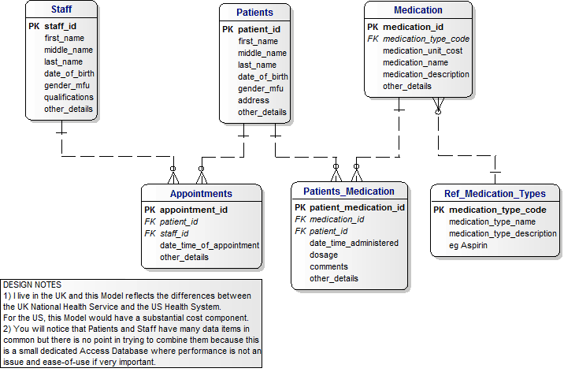

Modifications made to original design:

1. A new staff type entity was created for reference in order to label the type of doctors working at the health centre, this also helps to identify the type of doctor each patient came in to see.
2. A new pay scale entity was created to define the minimum and maximum salary of each staff type to aid the information required for a staff type entity.
3. New attributes were added to the Staff and Patient entities for additional details.
4. Alterations have also been made to attribute titles for a better, simpler naming convention.

**New Health Centre Diagram**

The ER diagram presented is a result of these changes made to the original design.

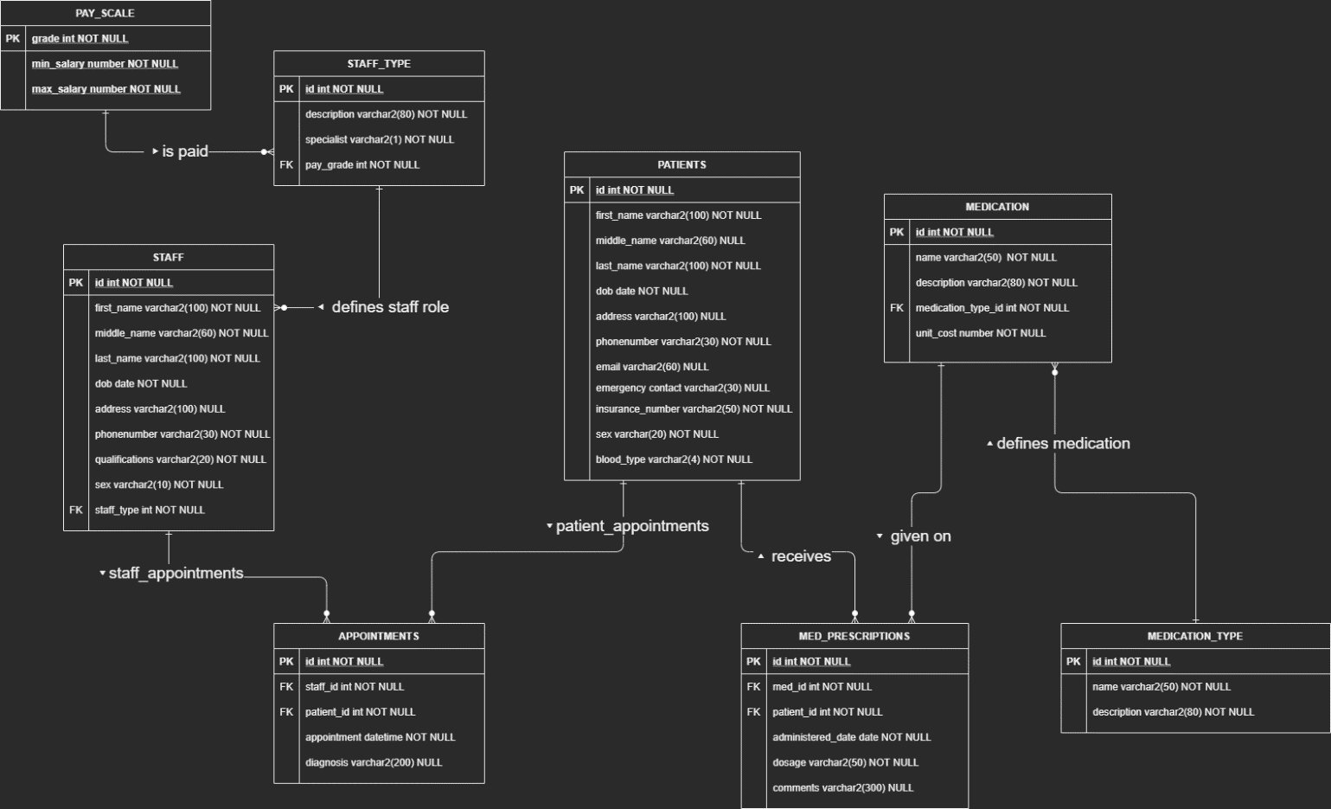

## **Reference**

Reference to original ER diagram: <http://www.databaseanswers.org/data_models/health_centres/index.htm>

# **Task B: Proposed Report**

The realistic report will be an account of all appointments conducted by specialists for each month with a total for the current year. The report will utilize data from tables STAFF_TYPE, STAFF & APPOINTMENTS, using an aggregate function to determine the monthly appointments.

Relational Algebra detailing report:

π st.description, a. appointment, a.id (σ st.specialist = ‘y’, a.appointment > ’01-JAN-2021’ ^ a.appointment < ’30-DEC-2021’ (staff_type st ⋈ st.id = s.staff_type staff s ⋈ s.id = a.staff_id appointments a ))

# **Task C: Test Plan**

On creation of the database data consistency, quality and integrity will be ensured by applying the necessary contraints, rules as well as implementing the use of a simpler naming comvention as mentioned in the changes to the original design. Abiding by the 4 C’s of data quality will ensure the validity of the realistic report. The report will be returning the type of staff who are specialists (description), the months of the year that has had an appointment or will have (appointment) and the total amount of appointments done for each month (id).

The test data created will be based on my own research (medications, medication types, various types of doctors) to populate the health centre database. The data needed for the report will come from the staff_type table which is used to find doctors who are specialists, the staff table which have many doctors of various types that conduct appointments throughout the year which will be present in the appoitntments table which serves as a log for every appointment conducted or scheduled for the year. This data would then provide a substantial monthly report for specialists.

To confirm the accuracy of the report results, verifying the correctness of data is of utmost importance. The inserted data for all specialists and appointments will be referenced to validate the report results (staff type, appointment_date & count(appointmets) of each month and total roll up. A second validation will be done through the use of a SQL script to spot check monthly data for specialists as well as appointments as well as to check that the valid specialists (staff) are being included into the report results. Doing these checks will help me to determine if my report is functioning as expected, which is a current year report of all appointments conducted or scheduled for specialist doctors working at the health centre.

# **Task D: Scheme & Normalization**

Modifications made to first design: Changes were made after feedback.

1. PAY_SCALE: min_salary & max_salary updated from NUMBER datatype to DECIMAL (10,2).
2. STAFF_TYPE: description size reduced from VARCHAR(80) to VARCHAR(30) suitable to save storage space.
3. STAFF: first_name, middle_name & last_name size reduced to VARCHAR(30). phonenumber reduced to VARCHAR(18) & sex reduced to VARCHAR(10). Changes were made to improve storage space.
4. PATIENTS: first_name, middle_name & last_name size reduced to VARCHAR(30). phonenumber & emergency_contact reduced to VARCHAR(18) & sex reduced to VARCHAR(10). Changes were made to improve storage space.
5. MEDICATION: name reduced to VARCHAR(30), unit_cost updated from NUMBER datatype to DECIMAL (10,2).

## **Relational Schema**

PAY_SCALE(grade, min_salary_number, max_salary_number)

STAFF_TYPE(id, description, specialist, *pay_grade*)

STAFF(id, first_name, middle_name, last_name, dob, address, phonenumber, qualifications, sex, *staff_type*)

APPOINTMENTS(id, *staff_id*, *patient_id*, appointment, diagnosis)

PATIENTS (id, first_name, middle_name, last_name, dob, address, phonenumber, email, emergency_contact, insurance_number**,** sex, blood_type)

MED_PRESCRIPTIONS(id, med_id, patient_id, administered_date, dosage, comments)

MEDICATION(id, name, description, *medication_type*, unit_cost)

MEDICATION_TYPE(id, name, description)

## **First Normal Form**

* All rows must be unique (no duplicate rows)
* Each cell must only contain a single value (not a list)
* Each value should be non divisible (can’t be split down further)

1) The pay_scale schema meets 1NF with grade as its unique identifier. Ensuring each row is unique, containing no repeating groups. No Changes needed for schema.

2) The staff_type schema meets 1NF with id as its unique identifier. Ensuring each row is unique, containing no repeating groups. No Changes needed for schema.

3) The staff schema meets 1NF with id as its unique identifier. Ensuring each row is unique, containing no repeating groups. No Changes needed for schema.

4) The appointments schema meets 1NF with id as its unique identifier. Ensuring each row is unique, containing no repeating groups. No Changes needed for schema.

5) The patients schema meets 1NF with id as its unique identifier. Ensuring each row is unique, containing no repeating groups. No Changes needed for schema.

6) The med_prescriptions schema meets 1NF with id as its unique identifier. Ensuring each row is unique, containing no repeating groups. No Changes needed for schema.

7) The medication schema meets 1NF with id as its unique identifier. Ensuring each row is unique, containing no repeating groups. No Changes needed for schema.

8) The medication_type schema meets 1NF with id as its unique identifier. Ensuring each row is unique, containing no repeating groups. No Changes needed for schema.

## **Second Normal Form**

* Database must be in First Normal Form
* No partial dependencies

1) The pay_scale schema is already in 2NF. The min_salary_number & max_salary_number are fully dependent on the primary key. No Changes needed for schema.

2) The staff_type schema is already in 2NF. The description, specialist & pay_grade are all depedent on the primary key. No Changes needed for schema.

3) The staff schema is already in 2NF. The first_name, middle_name, last_name, dob, address, phonenumber, qualifications, sex & staff_type are fully dependent on its primary key. No Changes needed for schema.

4) The appointments schema is already in 2NF. The staff_id, patient_id, appointment, diagnosis are fully dependent on its primary key. No Changes needed for schema.

5) The patients schema is already in 2NF. The first_name, middle_name, last_name, dob, address, phonenumber, email, emergency_contact, insurance_number, sex, blood_type are fully dependent on its primary key. No Changes needed for schema.

6) The med_prescriptions schema is already in 2NF. The med_id, patient_id, administered_date, dosage & comments are fully dependent on its primary key. No Changes needed for schema.

7) The medication schema is already in 2NF. The name, description, *medication_type* & unit_cost are fully dependent on its primary key. No Changes needed for schema.

8) The medication_type schema is already in 2NF. The name & description are fully dependent on its primary key. No Changes needed for schema.

## **Third Normal Form**

* Database must be in First & Second Normal Form
* No transitive dependencies

1) The pay_scale schema is already in 3NF. This schema contains no transitive dependencies, all fields are determined by the primary key.

2) The staff_TYPE schema does not meet 3NF. The field desciption can uniquely identify staff type and pay_grade.

New Schema: STAFF_TYPE(id, description, level, specialist, *pay_grade*)

The staff_type schema is now in 3NF, staff on different levels can share the same pay_grade and specialist Identification.

3) The staff schema does not meet 3NF. The field phonenumber can uniquely identify each staff member, this schema will need to be modified to meet 3NF.

New Schema: STAFF(id, first_name, middle_name, last_name, dob, address, homephone, qualifications, sex, *staff_type*)

The staff schema is now in 3NF, homephones are likely shared between room mates and couples living together.

4) The appointments schema is already in 3NF. This schema contains no transitive dependencies, all fields are determined by the primary key.

5) The patient schema does not meet 3NF. The field phonenumber can uniquely identify each patient member, this schema will need to be modified to meet 3NF.

New Schema: PATIENTS (id, first_name, middle_name, last_name, dob, address, homephone, email, emergency_contact, insurance_number**,** sex, blood_type)

The patient schema is now in 3NF, homephones are likely shared between room mates and couples living together.

6) The med_prescriptions schema is already in 3NF. This schema contains no transitive dependencies, all fields are determined by the primary key.

7) The medication schema does not meet 3NF. The field name can uniquely identify other schema keys, this schema will need to be modified to meet 3NF.

New Schema: MEDICATION(id, name, description, dosage_form, *medication_type*, unit_cost)

The med_prescriptions schema is now in 3NF, every brand of medication can come in various dosage forms. Dosage will be removed from med_prescriptions.

8) The medication_type schema does not meet 3NF. The field name can uniquely identify other schema keys, this schema will need to be modified to meet 3NF.

New Schema: MEDICATION_TYPE(id, name, description, form)

The medication_type schema is now in 3NF, every type of medication can come in different forms.

## **Final Schema**

PAY_SCALE(grade, min_salary_number, max_salary_number)  
STAFF_TYPE(id, description, level, specialist, *pay_grade*)

STAFF(id, first_name, middle_name, last_name, dob, address, homephone, qualifications, sex, *staff_type*)

APPOINTMENTS(id, *staff_id*, *patient_id*, appointment, diagnosis)

PATIENTS (id, first_name, middle_name, last_name, dob, address, homephone, email, emergency_contact, insurance_number**,** sex, blood_type)

MED_PRESCRIPTIONS(id, med_id, patient_id, administered_date, comments)

MEDICATION(id, name, description, dosage_form, *medication_type*, unit_cost)

MEDICATION_TYPE(id, name, description, form)

## **Final ERD**

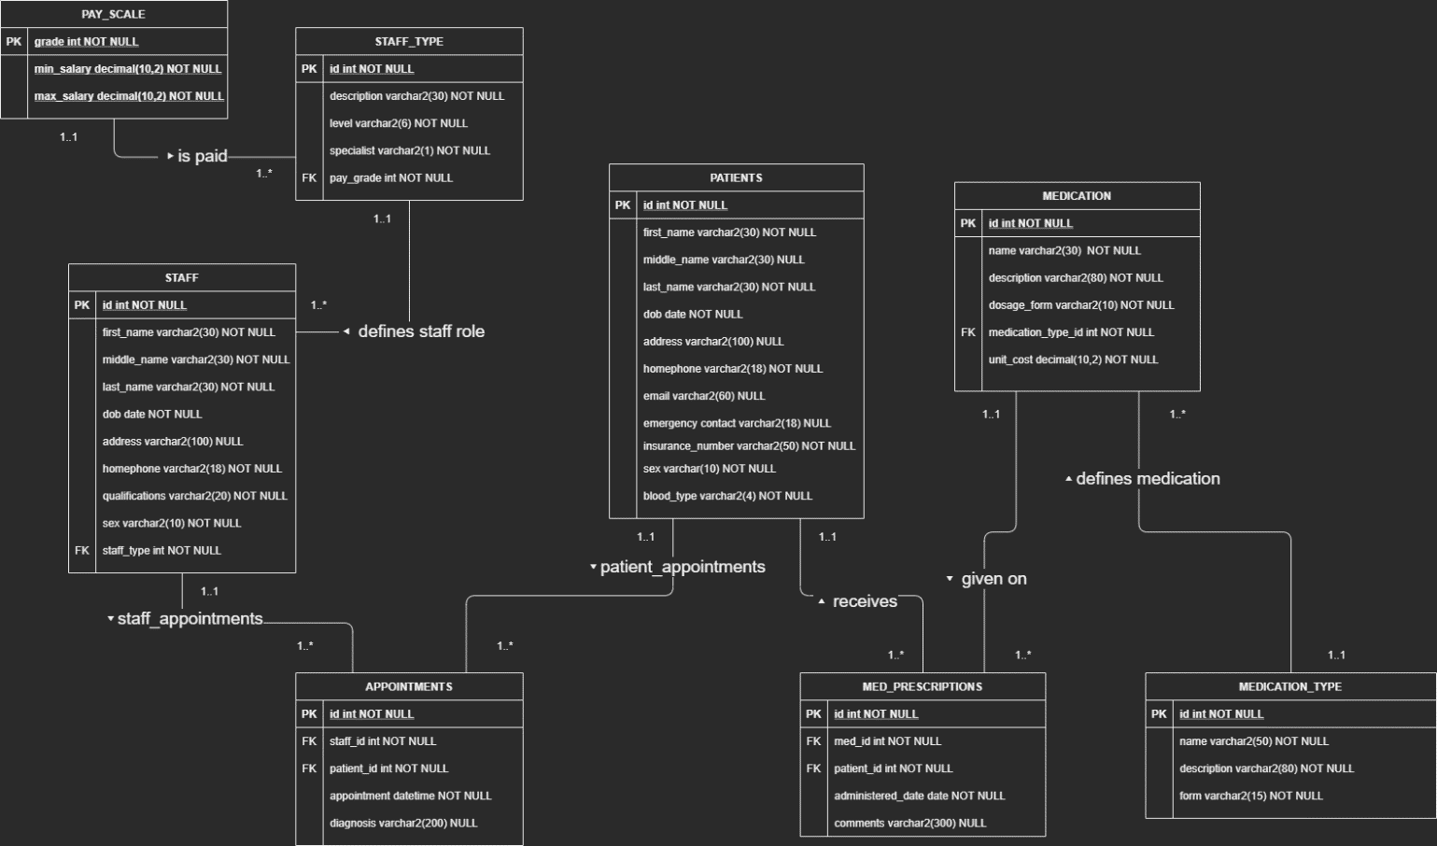

This is the final ERD of my database after the specified changesto attributes and taking each entity through normalization (1NF, 2NF, & 3NF)

# **Task E: Implementation – DDL and DML**

The implementation of my database was done using the application DBeaver.

All tables exist on the server soc-web-liv-11:

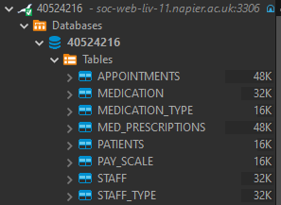

Attached are my DDL & DML statements used to create the database and import data.

 

The code SET sql_mode='oracle'; was used to make table creation and data insertion run smoothly. All creation and insert scripts ran without any issues. Every entity consists of 10 or more rows, snippest are provided in the report below of each DDL & DML statement.

## **DDL and DML: PAY_SCALE**

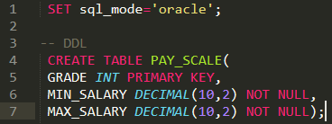 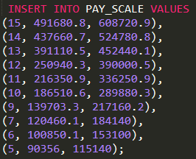

## **DDL and DML: STAFF_TYPE**

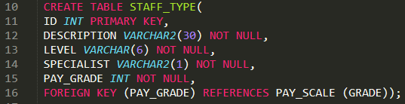

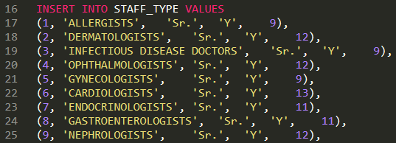

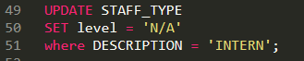

## **DDL and DML: STAFF**

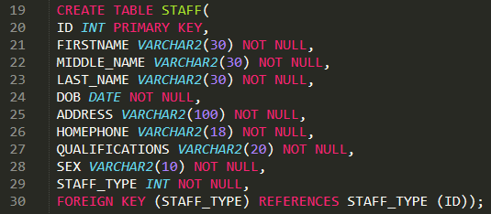

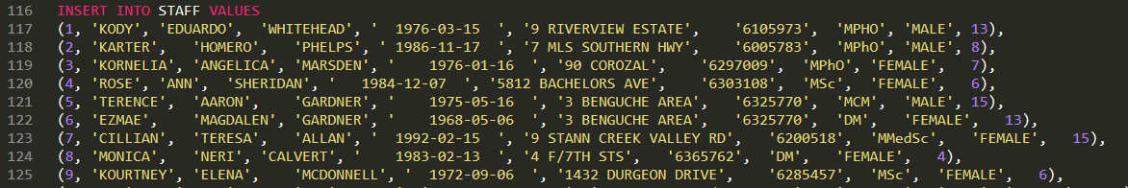

## **DDL and DML: APPOINTMENTS**

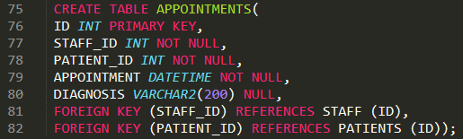

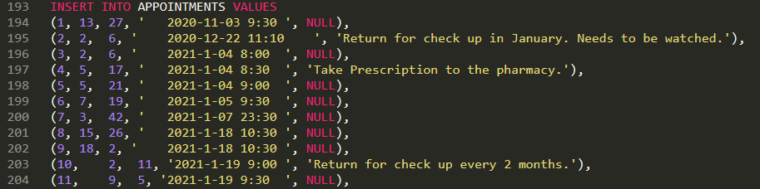

## **DDL and DML: PATIENTS**

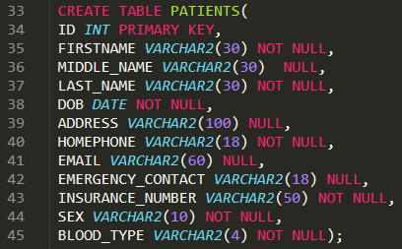

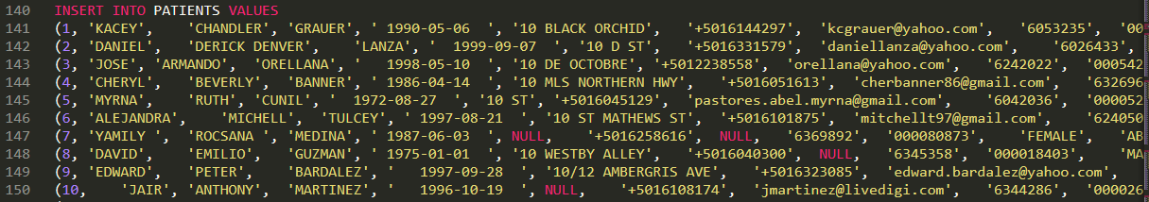

## **DDL and DML: MED_PRESCRIPTIONS**

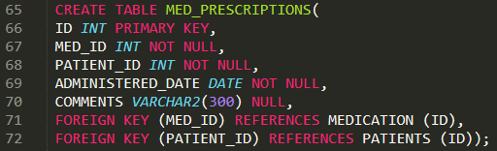

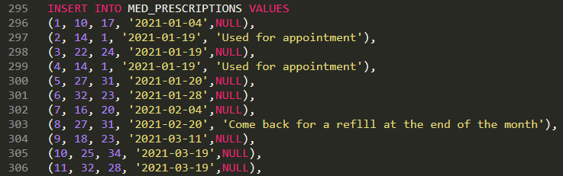

## **DDL and DML: MEDICATION**

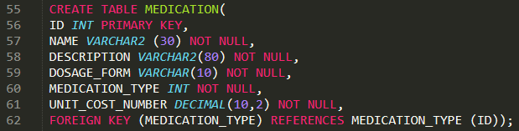

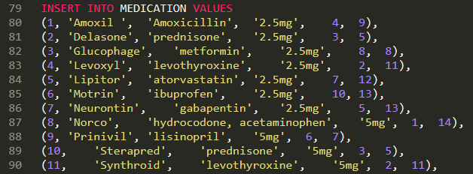

## **DDL and DML: MEDICATION_TYPE**

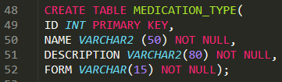

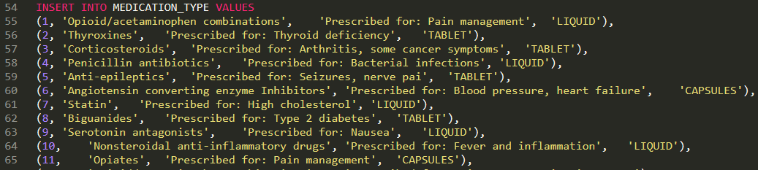

# **Task F: Report**

## **SQL Report:**



Below is my structured query for the report: The realistic report will be an account of all appointments conducted by specialists for each month with a total for the current year. The report will utilize data from tables STAFF_TYPE, STAFF & APPOINTMENTS, using an aggregate function to determine the monthly appointments.

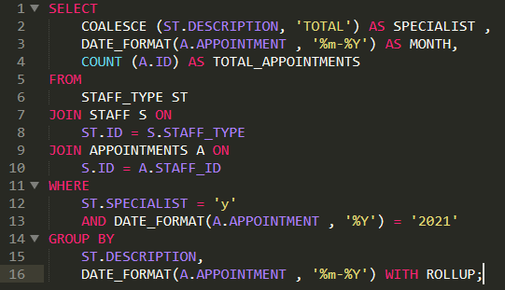

The report provide a breakdown for each specialist and their appointments for each month within the year of 2021 with a total rollup.

SQL Verification Scripts:



**Report Results and Testing:**

Report Output:

  
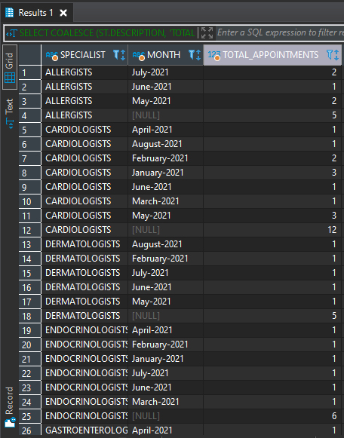

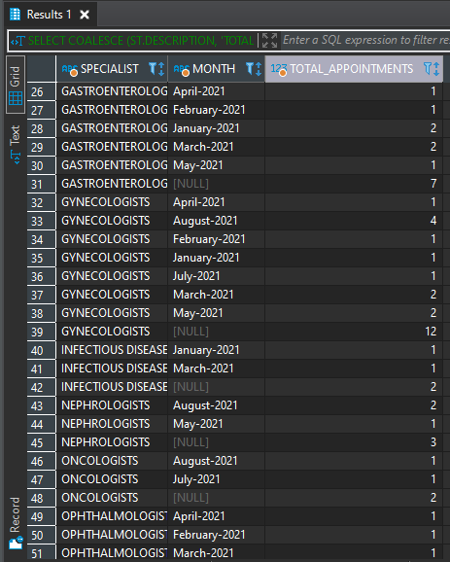

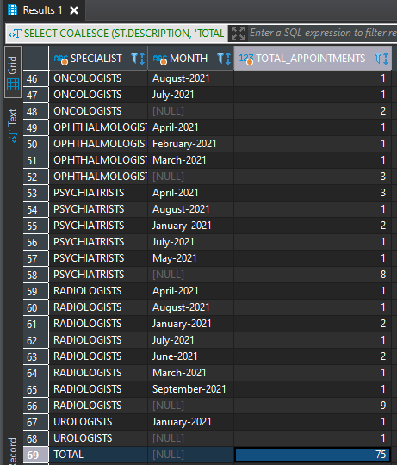

Based on the test data that was created for my database, this report is returning the appropriate information as expected. The test data (Inserted Data) was filtered and referenced in ordered to spot check the report’s results which confirms the report is accurate with the expected data. The data from the report was also verified using the queries down below to spot check specialist appointments and that the appropriate appointments were included.

Test Data:

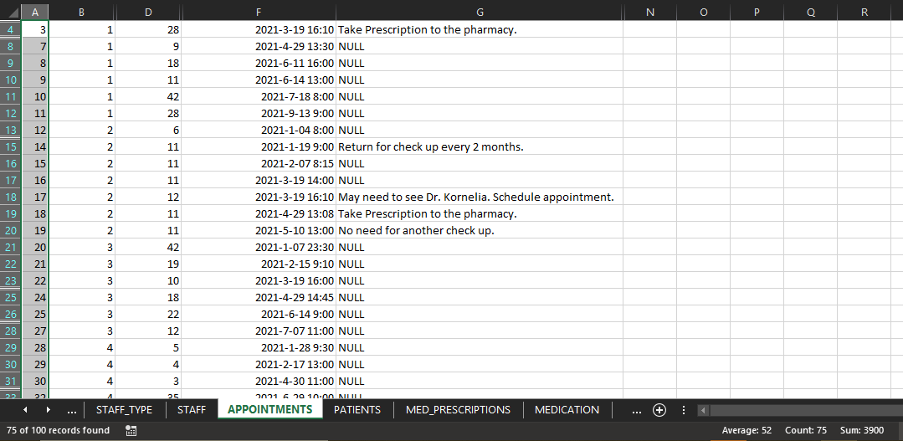

Test Data File:



## **Verification Scripts:**

SQL used to verify Cardiologist appointments:  
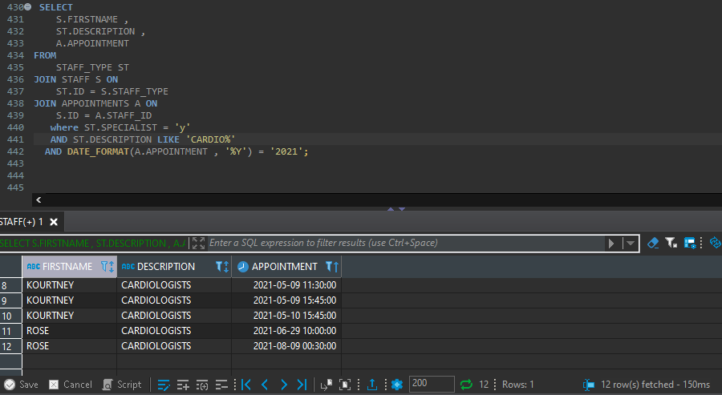

SQL used to verify total appointments for specialists:

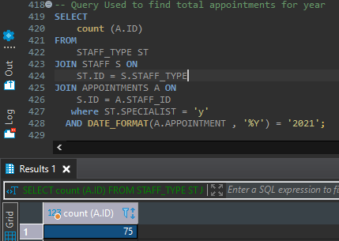

SQL used to verify Gastroenterologists appointments:

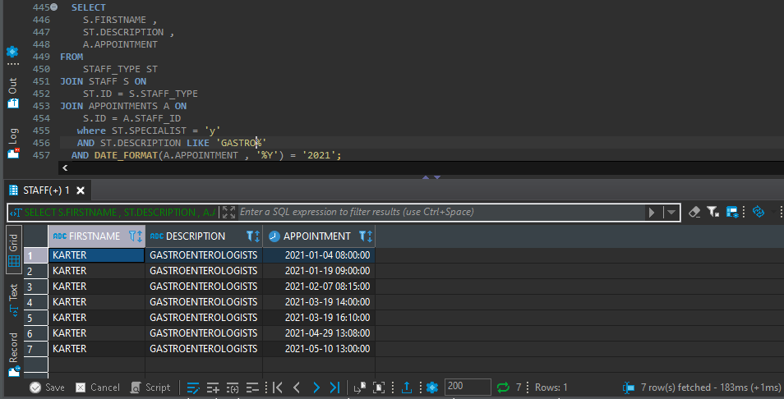

SQL used to verify specialists:

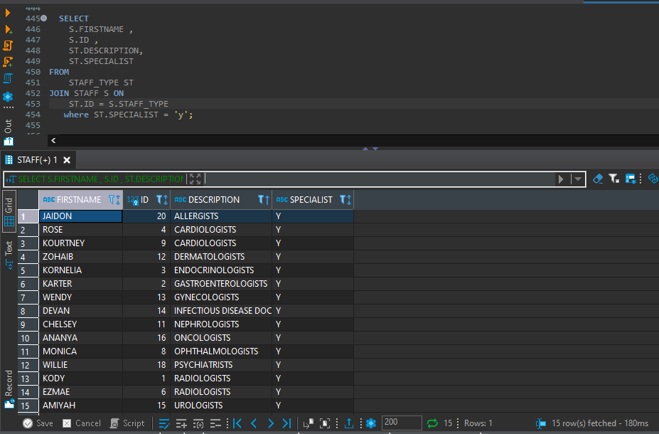

# **Appendix**

## **DDL STATEMENTS:**

SET sql_mode='oracle';

-- DDL

CREATE TABLE PAY_SCALE(

GRADE INT PRIMARY KEY,

MIN_SALARY DECIMAL(10,2) NOT NULL,

MAX_SALARY DECIMAL(10,2) NOT NULL);

CREATE TABLE STAFF_TYPE(

ID INT PRIMARY KEY,

DESCRIPTION VARCHAR2(30) NOT NULL,

LEVEL VARCHAR(6) NOT NULL,

SPECIALIST VARCHAR2(1) NOT NULL,

PAY_GRADE INT NOT NULL,

FOREIGN KEY (PAY_GRADE) REFERENCES PAY_SCALE (GRADE));

CREATE TABLE STAFF(

ID INT PRIMARY KEY,

FIRSTNAME VARCHAR2(30) NOT NULL,

MIDDLE_NAME VARCHAR2(30) NOT NULL,

LAST_NAME VARCHAR2(30) NOT NULL,

DOB DATE NOT NULL,

ADDRESS VARCHAR2(100) NOT NULL,

HOMEPHONE VARCHAR2(18) NOT NULL,

QUALIFICATIONS VARCHAR2(20) NOT NULL,

SEX VARCHAR2(10) NOT NULL,

STAFF_TYPE INT NOT NULL,

FOREIGN KEY (STAFF_TYPE) REFERENCES STAFF_TYPE (ID));

CREATE TABLE PATIENTS(

ID INT PRIMARY KEY,

FIRSTNAME VARCHAR2(30) NOT NULL,

MIDDLE_NAME VARCHAR2(30) NULL,

LAST_NAME VARCHAR2(30) NOT NULL,

DOB DATE NOT NULL,

ADDRESS VARCHAR2(100) NULL,

HOMEPHONE VARCHAR2(18) NOT NULL,

EMAIL VARCHAR2(60) NULL,

EMERGENCY_CONTACT VARCHAR2(18) NULL,

INSURANCE_NUMBER VARCHAR2(50) NOT NULL,

SEX VARCHAR2(10) NOT NULL,

BLOOD_TYPE VARCHAR2(4) NOT NULL);

CREATE TABLE MEDICATION_TYPE(

ID INT PRIMARY KEY,

NAME VARCHAR2 (50) NOT NULL,

DESCRIPTION VARCHAR2(80) NOT NULL,

FORM VARCHAR(15) NOT NULL);

CREATE TABLE MEDICATION(

ID INT PRIMARY KEY,

NAME VARCHAR2 (30) NOT NULL,

DESCRIPTION VARCHAR2(80) NOT NULL,

DOSAGE_FORM VARCHAR(10) NOT NULL,

MEDICATION_TYPE INT NOT NULL,

UNIT_COST_NUMBER DECIMAL(10,2) NOT NULL,

FOREIGN KEY (MEDICATION_TYPE) REFERENCES MEDICATION_TYPE (ID));

CREATE TABLE MED_PRESCRIPTIONS(

ID INT PRIMARY KEY,

MED_ID INT NOT NULL,

PATIENT_ID INT NOT NULL,

ADMINISTERED_DATE DATE NOT NULL,

COMMENTS VARCHAR2(300) NULL,

FOREIGN KEY (MED_ID) REFERENCES MEDICATION (ID),

FOREIGN KEY (PATIENT_ID) REFERENCES PATIENTS (ID));

CREATE TABLE APPOINTMENTS(

ID INT PRIMARY KEY,

STAFF_ID INT NOT NULL,

PATIENT_ID INT NOT NULL,

APPOINTMENT DATETIME NOT NULL,

DIAGNOSIS VARCHAR2(200) NULL,

FOREIGN KEY (STAFF_ID) REFERENCES STAFF (ID),

FOREIGN KEY (PATIENT_ID) REFERENCES PATIENTS (ID));

## **DML STATEMENTS:**

SET sql_mode='oracle';

INSERT INTO PAY_SCALE VALUES

(15, 491680.8, 608720.9),

(14, 437660.7, 524780.8),

(13, 391110.5, 452440.1),

(12, 250940.3, 390000.5),

(11, 216350.9, 336250.9),

(10, 186510.6, 289880.3),

(9, 139703.3, 217160.2),

(7, 120460.1, 184140),

(6, 100850.1, 153100),

(5, 90356, 115140);

INSERT INTO STAFF_TYPE VALUES

(1, 'ALLERGISTS', 'Sr.', 'Y', 9),

(2, 'DERMATOLOGISTS', 'Sr.', 'Y', 12),

(3, 'INFECTIOUS DISEASE DOCTORS', 'Sr.', 'Y', 9),

(4, 'OPHTHALMOLOGISTS', 'Sr.', 'Y', 12),

(5, 'GYNECOLOGISTS', 'Sr.', 'Y', 9),

(6, 'CARDIOLOGISTS', 'Sr.', 'Y', 13),

(7, 'ENDOCRINOLOGISTS', 'Sr.', 'Y', 11),

(8, 'GASTROENTEROLOGISTS', 'Sr.', 'Y', 11),

(9, 'NEPHROLOGISTS', 'Sr.', 'Y', 12),

(10, 'UROLOGISTS', 'Sr.', 'Y', 9),

(11, 'PSYCHIATRISTS', 'Sr.', 'Y', 10),

(12, 'ONCOLOGISTS', 'Sr.', 'Y', 11),

(13, 'RADIOLOGISTS', 'Sr.', 'Y', 15),

(14, 'GERIATRICIANS', 'Sr.', 'N', 7),

(15, 'PEDIATRICIANS', 'Sr.', 'N', 6),

(16, 'ALLERGISTS', 'Jr.', 'N', 9),

(17, 'DERMATOLOGISTS', 'Jr.', 'Y', 12),

(18, 'INFECTIOUS DISEASE DOCTORS', 'Jr.', 'Y', 9),

(19, 'OPHTHALMOLOGISTS', 'Jr.', 'Y', 12),

(20, 'GYNECOLOGISTS', 'Jr.', 'Y', 9),

(21, 'CARDIOLOGISTS', 'Jr.', 'Y', 13),

(22, 'ENDOCRINOLOGISTS', 'Jr.', 'Y', 11),

(23, 'GASTROENTEROLOGISTS', 'Jr.', 'Y', 11),

(24, 'NEPHROLOGISTS', 'Jr.', 'Y', 12),

(25, 'UROLOGISTS', 'Jr.', 'Y', 9),

(26, 'PSYCHIATRISTS', 'Jr.', 'Y', 10),

(27, 'ONCOLOGISTS', 'Jr.', 'Y', 11),

(28, 'RADIOLOGISTS', 'Jr.', 'Y', 14),

(29, 'GERIATRICIANS', 'Jr.', 'N', 6),

(30, 'PEDIATRICIANS', 'Jr.', 'N', 5),

(31, 'INTERN', '', 'N', 5);

UPDATE STAFF_TYPE

SET level = 'N/A'

where DESCRIPTION = 'INTERN';

INSERT INTO MEDICATION_TYPE VALUES

(1, 'Opioid/acetaminophen combinations', 'Prescribed for: Pain management', 'LIQUID'),

(2, 'Thyroxines', 'Prescribed for: Thyroid deficiency', 'TABLET'),

(3, 'Corticosteroids', 'Prescribed for: Arthritis, some cancer symptoms', 'TABLET'),

(4, 'Penicillin antibiotics', 'Prescribed for: Bacterial infections', 'LIQUID'),

(5, 'Anti-epileptics', 'Prescribed for: Seizures, nerve pai', 'TABLET'),

(6, 'Angiotensin converting enzyme Inhibitors', 'Prescribed for: Blood pressure, heart failure', 'CAPSULES'),

(7, 'Statin', 'Prescribed for: High cholesterol', 'LIQUID'),

(8, 'Biguanides', 'Prescribed for: Type 2 diabetes', 'TABLET'),

(9, 'Serotonin antagonists', 'Prescribed for: Nausea', 'LIQUID'),

(10, 'Nonsteroidal anti-inflammatory drugs', 'Prescribed for: Fever and inflammation', 'LIQUID'),

(11, 'Opiates', 'Prescribed for: Pain management', 'CAPSULES'),

(12, 'Opioid/acetaminophen combinations', 'Prescribed for: Pain management', 'CAPSULES'),

(13, 'Thyroxines', 'Prescribed for: Thyroid deficiency', 'LIQUID'),

(14, 'Corticosteroids', 'Prescribed for: Arthritis, some cancer symptoms', 'TABLET'),

(15, 'Penicillin antibiotics', 'Prescribed for: Bacterial infections', 'LIQUID'),

(16, 'Anti-epileptics', 'Prescribed for: Seizures, nerve pai', 'LIQUID'),

(17, 'Angiotensin converting enzyme Inhibitors', 'Prescribed for: Blood pressure, heart failure', 'CAPSULES'),

(18, 'Statin', 'Prescribed for: High cholesterol', 'LIQUID'),

(19, 'Biguanides', 'Prescribed for: Type 2 diabetes', 'TABLET'),

(20, 'Serotonin antagonists', 'Prescribed for: Nausea', 'TABLET'),

(21, 'Nonsteroidal anti-inflammatory drugs', 'Prescribed for: Fever and inflammation', 'LIQUID'),

(22, 'Opiates', 'Prescribed for: Pain management', 'SUPPOSITORIES');

INSERT INTO MEDICATION VALUES

(1, 'Amoxil ', 'Amoxicillin', '2.5mg', 4, 9),

(2, 'Delasone', 'prednisone', '2.5mg', 3, 5),

(3, 'Glucophage', 'metformin', '2.5mg', 8, 8),

(4, 'Levoxyl', 'levothyroxine', '2.5mg', 2, 11),

(5, 'Lipitor', 'atorvastatin', '2.5mg', 7, 12),

(6, 'Motrin', 'ibuprofen', '2.5mg', 10, 13),

(7, 'Neurontin', 'gabapentin', '2.5mg', 5, 13),

(8, 'Norco', 'hydrocodone, acetaminophen', '5mg', 1, 14),

(9, 'Prinivil', 'lisinopril', '5mg', 6, 7),

(10, 'Sterapred', 'prednisone', '5mg', 3, 5),

(11, 'Synthroid', 'levothyroxine', '5mg', 2, 11),

(12, 'Unithroid', 'levothyroxine', '5mg', 2, 11),

(13, 'Vicodin', 'hydrocodone, acetaminophen', '5mg', 1, 14),

(14, 'Xodol', 'hydrocodone, acetaminophen', '5mg', 12, 14),

(15, 'Zestril', 'lisinopril', '5mg', 6, 7),

(16, 'Zofran', 'ondansetron', '5mg', 9, 12),

(17, 'Amoxil ', 'Amoxicillin', '5mg', 4, 9),

(18, 'Delasone', 'prednisone', '5mg', 3, 5),

(19, 'Glucophage', 'metformin', '5mg', 8, 8),

(20, 'Levoxyl', 'levothyroxine', '5mg', 2, 11),

(21, 'Lipitor', 'atorvastatin', '5mg', 7, 12),

(22, 'Motrin', 'ibuprofen', '5mg', 10, 13),

(23, 'Neurontin', 'gabapentin', '5mg', 5, 13),

(24, 'Norco', 'hydrocodone, acetaminophen', '7.5mg', 1, 14),

(25, 'Prinivil', 'lisinopril', '7.5mg', 6, 7),

(26, 'Sterapred', 'prednisone', '7.5mg', 3, 5),

(27, 'Synthroid', 'levothyroxine', '7.5mg', 2, 11),

(28, 'Unithroid', 'levothyroxine', '7.5mg', 13, 11),

(29, 'Vicodin', 'hydrocodone, acetaminophen', '7.5mg', 1, 14),

(30, 'Xodol', 'hydrocodone, acetaminophen', '7.5mg', 12, 14),

(31, 'Zestril', 'lisinopril', '7.5mg', 6, 7),

(32, 'Zofran', 'ondansetron', '7.5mg', 20, 12),

(33, 'Demerol', 'Meperidine ', '5mg', 11, 11);

INSERT INTO STAFF VALUES

(1, 'KODY', 'EDUARDO', 'WHITEHEAD', ' 1976-03-15 ', '9 RIVERVIEW ESTATE', '6105973', 'MPHO', 'MALE', 13),

(2, 'KARTER', 'HOMERO', 'PHELPS', ' 1986-11-17 ', '7 MLS SOUTHERN HWY', '6005783', 'MPhO', 'MALE', 8),

(3, 'KORNELIA', 'ANGELICA', 'MARSDEN', ' 1976-01-16 ', '90 COROZAL', '6297009', 'MPhO', 'FEMALE', 7),

(4, 'ROSE', 'ANN', 'SHERIDAN', ' 1984-12-07 ', '5812 BACHELORS AVE', '6303108', 'MSc', 'FEMALE', 6),

(5, 'TERENCE', 'AARON', 'GARDNER', ' 1975-05-16 ', '3 BENGUCHE AREA', '6325770', 'MCM', 'MALE', 15),

(6, 'EZMAE', 'MAGDALEN', 'GARDNER', ' 1968-05-06 ', '3 BENGUCHE AREA', '6325770', 'DM', 'FEMALE', 13),

(7, 'CILLIAN', 'TERESA', 'ALLAN', ' 1992-02-15 ', '9 STANN CREEK VALLEY RD', '6200518', 'MMedSc', 'FEMALE', 15),

(8, 'MONICA', 'NERI', 'CALVERT', ' 1983-02-13 ', '4 F/7TH STS', '6365762', 'DM', 'FEMALE', 4),

(9, 'KOURTNEY', 'ELENA', 'MCDONNELL', ' 1972-09-06 ', '1432 DURGEON DRIVE', '6285457', 'MSc', 'FEMALE', 6),

(10, 'NIKKI', 'MARIELA', 'SWEENEY', ' 1979-03-19 ', '3753 C A BLVD/RACOON ST', '6230452', 'MPHO', 'FEMALE', 29),

(11, 'CHELSEY', 'TERESITA', 'NOBLE', ' 1971-08-20 ', '1D SUNSET APTS', '6208105', 'MSc', 'FEMALE', 9),

(12, 'ZOHAIB', 'ALFONSO', 'WEBB', ' 1984-03-13 ', 'BITTER WOOD ST', '6267077', 'DO', 'MALE', 2),

(13, 'WENDY', 'LYNN', 'MCKEOWN', ' 1976-03-17 ', '68 HOLLYWOOD ', '6050586', 'MMedSc', 'FEMALE', 5),

(14, 'DEVAN', 'ALVIN', 'FERRY', ' 1996-01-12 ', '9 YOUNG', '6343284', 'DM', 'MALE', 18),

(15, 'AMIYAH', 'LOU', 'LEAL', ' 1970-05-19 ', '134 JELLYFISH DR', '6089773', 'MSc', 'FEMALE', 10),

(16, 'ANANYA', 'ROSE', 'BAUER', ' 1969-04-02 ', '58 LOS LAGOS', '6236383', 'MPHO', 'FEMALE', 12),

(17, 'KEON', 'NELSON', 'HAMMOND', ' 1968-04-21 ', '46 PRICE BARRACKS', '6202687', 'MMedSc', 'MALE', 14),

(18, 'WILLIE', 'MATTHEW', 'EDMONDS', ' 1967-08-27 ', '15 MLS WESTERN HWY', '6028335', 'DM', 'MALE', 11),

(19, 'JOCELYN', 'CRISTELIA', 'MONTGOMERY', ' 1980-08-24 ', '90 CHURCHILL ST', '6204220', 'MPhO', 'FEMALE', 14),

(20, 'JAIDON', 'MURCIA OMAR DE', 'STAFFORD', ' 1967-02-04 ', '5 BACADERA AREA SUNSET POINT', '6237462', 'MPHO', 'MALE', 1);

INSERT INTO PATIENTS VALUES

(1, 'KACEY', 'CHANDLER', 'GRAUER', ' 1990-05-06 ', '10 BLACK ORCHID', '+5016144297', 'kcgrauer@yahoo.com', '6053235', '000162621', 'FEMALE', 'A+'),

(2, 'DANIEL', 'DERICK DENVER', 'LANZA', ' 1999-09-07 ', '10 D ST', '+5016331579', 'daniellanza@yahoo.com', '6026433', '000019005', 'MALE', 'A-'),

(3, 'JOSE', 'ARMANDO', 'ORELLANA', ' 1998-05-10 ', '10 DE OCTOBRE', '+5012238558', 'orellana@yahoo.com', '6242022', '000542522', 'MALE', 'B+'),

(4, 'CHERYL', 'BEVERLY', 'BANNER', ' 1986-04-14 ', '10 MLS NORTHERN HWY', '+5016051613', 'cherbanner86@gmail.com', '6326969', '000085365', 'FEMALE', 'B-'),

(5, 'MYRNA', 'RUTH', 'CUNIL', ' 1972-08-27 ', '10 ST', '+5016045129', 'pastores.abel.myrna@gmail.com', '6042036', '000052739', 'FEMALE', 'O+'),

(6, 'ALEJANDRA', 'MICHELL', 'TULCEY', ' 1997-08-21 ', '10 ST MATHEWS ST', '+5016101875', 'mitchellt97@gmail.com', '6240505', '000045187', 'FEMALE', 'O-'),

(7, 'YAMILY ', 'ROCSANA ', 'MEDINA', ' 1987-06-03 ', NULL, '+5016258616', NULL, '6369892', '000080873', 'FEMALE', 'AB+'),

(8, 'DAVID', 'EMILIO', 'GUZMAN', ' 1975-01-01 ', '10 WESTBY ALLEY', '+5016040300', NULL, '6345358', '000018403', 'MALE', 'AB-'),

(9, 'EDWARD', 'PETER', 'BARDALEZ', ' 1997-09-28 ', '10/12 AMBERGRIS AVE', '+5016323085', 'edward.bardalez@yahoo.com', '2238557', '000037354', 'MALE', 'AB+'),

(10, 'JAIR', 'ANTHONY', 'MARTINEZ', ' 1996-10-19 ', NULL, '+5016108174', 'jmartinez@livedigi.com', '6344286', '000026577', 'MALE', 'A-'),

(11, 'KAMAU ', 'RUDO', 'STRAUGHAN', ' 1998-01-10 ', '102 NEW LOUISIANA', '+5011234567', NULL, NULL, '000011748', 'MALE', 'B+'),

(12, 'ERNESTINE', 'ELLORINE', 'JACKSON', ' 1979-07-03 ', '102 SYLVESTER BLVD', '+5016026054', 'ellorinejackson@gmail.com', '6088841', '000000461', 'MALE', 'B-'),

(13, 'DENNIS', 'EDWARD', 'PLUMMER', ' 1991-09-22 ', '103A LORD BANK', '+5016666666', NULL, NULL, '000060793', 'MALE', 'O+'),

(14, 'WILLIAM', 'ALRICK', 'DAWSON', ' 1996-12-25 ', '1042 BLACK CORAL DR', '+5016364073', NULL, '2260169', '000033352', 'MALE', 'O-'),

(15, 'FREDERICK', 'ARTHUR', 'TILLETT', ' 1977-09-12 ', '1088 COTTONWICK ST', '+5011234567', NULL, '6303190', '000044351', 'MALE', 'AB+'),

(16, 'ROSITA', 'ESMERALDA', 'GARCIA', ' 1997-02-07 ', NULL, '+5016691600', 'garciarosa.e03@gmail.com', '6307138', '000067103', 'FEMALE', 'AB'),

(17, 'KAYLA ', 'SHWNIQUE', 'FLOWERS', ' 1998-05-17 ', '14 MLS WESTERN HWY', '+5011234567', NULL, '6328660', '000059100', 'FEMALE', 'O-'),

(18, 'KENRICK', 'LEE', 'CHOCO', ' 1998-02-17 ', '14 PRINCESS MAGARET DR', '+5012260169', 'kenrickchoco@gmail.com', '6101579', '000098964', 'MALE', 'O+'),

(19, 'ALEJANDRO', 'AMALIO', 'NAH', ' 1976-11-16 ', '14 STANN CREEK VALLEY RD', '+5016347743', 'lizeth_nah@hotmail.com', '6224405', '000064759', 'MALE', 'O+'),

(20, 'LAURA', 'ESTEBAN', 'CHOCO', ' 1977-02-25 ', '14 PRINCESS MAGARET DR', '+5012260169', NULL, '1234567', '000098964', 'FEMALE', 'A+'),

(21, 'KEVIN', 'ALEXANDER', 'CORADO', ' 1996-01-14 ', '117 CEMETARY RD', '+5016149483', 'kevinalexcorado@gmail.com', '6221247', '000014707', 'MALE', 'O+'),

(22, 'ALICIA', 'CARMEN', 'MEDINA', ' 1995-08-16 ', '118 MLS WESTERN HWY', '+5016344059', NULL, NULL, '000087677', 'FEMALE', 'O+'),

(23, 'INGRID ', 'SAYURI ', 'PENA', ' 1990-03-28 ', '118 VISTA DEL MAR', '+5016207142', 'ingridsayuripena@gmail.com', '2260169', '000062883', 'FEMALE', 'A+'),

(24, 'SALOMON', 'EUGENIO', 'SANCHEZ', ' 1991-07-08 ', '119 FREETOWN RD/ST THOMAS ST', '+5016053235', NULL, '6303190', '000530903', 'MALE', 'O+'),

(25, 'JAIR', 'VINCENT', 'TUN', ' 1996-09-13 ', '19TH STREET', '+5016026433', 'jair_tun@yahoo.com', '6307138', '000003928', 'MALE', 'B+'),

(26, 'STEPHANIE', 'VIOLET ', 'WILLIAMS', ' 1979-11-17 ', NULL, '+5016242022', NULL, NULL, '000008453', 'MALE', 'O+'),

(27, 'MONIQUE', 'NICOLE', 'FRANKLIN', ' 1998-02-05 ', '1D SUNSET APTS', '+5016326969', 'monnifrank30@gmail.com', '6258616', '000050389', 'FEMALE', 'O+'),

(28, 'MARCOS', 'DAVID', 'VALERIO', ' 1992-12-12 ', '1EBONY CONCH SHELL BAY', '+5016042036', NULL, '6040300', '000054635', 'MALE', 'B+'),

(29, 'DESIREE', 'DENNISE', 'CRAWFORD', ' 1984-12-08 ', '1ST AVE', '+5016240505', NULL, '6323085', '000073749', 'FEMALE', 'AB+'),

(30, 'EDWIN', 'NICOLAS', 'PEREZ LOPEZ', ' 1992-10-08 ', '23RD ST', '+5016369892', 'rayloveme29@gmail.com', '6108174', '000010015', 'MALE', 'O+'),

(31, 'ZHANINE', 'BRIDGETTE', 'MOREY', ' 1997-11-29 ', '24 BAHAMAS ST', '+5016345358', 'zhaniemorey90@gmail.com', '1234567', '000044026', 'FEMALE', 'B+'),

(32, 'JOSE', 'MANUEL', 'QUIROZ', ' 1983-07-11 ', '24 MOSES LANE', '+5012238557', 'jose@yahoo.com', '6026054', '000058210', 'MALE', 'AB+'),

(33, 'DIANA', 'KARINA', 'DUBON', ' 1989-09-16 ', '24 MOSES LANE', '+5012238557', NULL, '1234567', '000071829', 'MALE', 'AB+'),

(34, 'JANSEN', 'ARISTARCHUS', 'OVERHOLT', ' 1994-06-26 ', '67 WESTERN HWY', '+5016224297', 'overholt94@gmail.com', '6691600', '000116415', 'MALE', 'A-'),

(35, 'EMILY', 'AMIRA', 'COLEMAN', ' 1996-11-20 ', '1211 NORTH RIVERSIDE ST', '+5016088841', NULL, '1234567', '000197497', 'FEMALE', 'O-'),

(36, 'WUILLIAM', 'YONY', 'CUYUCH', ' 1984-09-13 ', '123 MLS WESTERN HWY', '+5012250125', 'wulliam@gmail.com', '6354850', '000492105', 'MALE', 'A-'),

(37, 'JORGE', 'GOVINDA', 'AVELLA', ' 1981-01-18 ', '1235B ROCKFISH DRIVE', '+5012260169', NULL, '6347743', '000237961', 'MALE', 'AB+'),

(38, 'SHANIQUE ', 'ELIZABETH', 'CHEE', ' 1993-11-10 ', '124 VICTORIA/YORK STS', '+5016303190', 'shantrev@hotmail.com', '6379199', '000230012', 'FEMALE', 'O-'),

(39, 'BILMA', 'YOVANA', 'YAXCAL', ' 1990-06-23 ', '125 JOSEMARIA NUNEZ ST', '+5016307138', NULL, '6001240', '000180388', 'FEMALE', 'A-'),

(40, 'LUIS', 'ALFONSO', 'MARIN', ' 1981-10-05 ', '126 BOWEN ST', '+5016328660', NULL, '6510437', '000285610', 'MALE', 'AB+'),

(41, 'JOSE', 'SAUL', 'PINELO', ' 1988-01-18 ', '38 ORIOLE AVE', '+5016255915', NULL, '6374954', '000360865', 'MALE', 'AB+'),

(42, 'LUIS', 'ANTONIO', 'MEDINA', ' 1986-08-19 ', '38 REGENT / PRINCE ST', '+5016023434', NULL, '5222021', '000180079', 'MALE', 'O-'),

(43, 'JUAN', 'ALBERTO', 'LEMUS CORDERO', ' 1975-11-05 ', '38MLS WESTERN HWAY', '+5016025252', 'humbelize@gmail.com', '6204866', '000019041', 'MALE', 'B-'),

(44, 'MYNOR ALBERTO', 'FRANCO', 'CASTELLANOS', ' 1979-08-08 ', '4.5 INSIDE CROOKED TREE CROOKED TREE VILLAGE', '+5012260169', NULL, '6315479', '000030661', 'MALE', 'O-'),

(45, 'PATRICK', 'MARTIN', 'MERKEN', ' 1973-09-21 ', '3B RAINBOW HEIGHTS', '+5016308790', NULL, '6318425', '000277273', 'MALE', 'B+'),

(46, 'MARK', 'ANTHONY', 'CABRAL', ' 1987-09-01 ', '4 TAPIR ST', '+5016693633', 'markdishark@gmail.com', '6017252', '000006354', 'MALE', 'B-'),

(47, 'ARTURO', 'R', 'VASQUEZ', ' 1999-01-01 ', NULL, '+5016101579', 'avasquez@btl.net', '6101745', '000292987', 'MALE', 'AB+'),

(48, 'SOLI', 'EBELI', 'CASTELLANOS', ' 1993-11-11 ', '4.5 INSIDE CROOKED TREE CROOKED TREE VILLAGE', '+5012260169', 'ebelialvarado543@yahoo.com', '6296126', '000030661', 'FEMALE', 'AB+'),

(49, 'CHARLES', 'STEPHEN', 'BELISLE', ' 1992-05-12 ', '40 COSTA RICA ST', '+5011234567', NULL, '6319773', '000225949', 'MALE', 'O-'),

(50, 'MITCHELLE', 'JOAN', 'POLONIO', ' 1998-10-20 ', '40 SANTA RITA LAYOUT', '+5016221247', 'rishymartinez@gmail.com', '6018122', '000173722', 'FEMALE', 'B-');

INSERT INTO APPOINTMENTS VALUES

(1, 13, 27, ' 2020-11-03 9:30 ', NULL),

(2, 2, 6, ' 2020-12-22 11:10 ', 'Return for check up in January. Needs to be watched.'),

(3, 2, 6, ' 2021-1-04 8:00 ', NULL),

(4, 5, 17, ' 2021-1-04 8:30 ', 'Take Prescription to the pharmacy.'),

(5, 5, 21, ' 2021-1-04 9:00 ', NULL),

(6, 7, 19, ' 2021-1-05 9:30 ', NULL),

(7, 3, 42, ' 2021-1-07 23:30 ', NULL),

(8, 15, 26, ' 2021-1-18 10:30 ', NULL),

(9, 18, 2, ' 2021-1-18 10:30 ', NULL),

(10, 2, 11, '2021-1-19 9:00 ', 'Return for check up every 2 months.'),

(11, 9, 5, '2021-1-19 9:30 ', NULL),

(12, 18, 1, '2021-1-19 9:30 ', 'Take Prescription to the pharmacy.'),

(13, 19, 24, '2021-1-19 9:30 ', 'Take Prescription to the pharmacy.'),

(14, 6, 18, '2021-1-19 10:30 ', 'Return for another check up.'),

(15, 6, 31, '2021-1-20 9:30 ', 'Take Prescription to the pharmacy.'),

(16, 13, 27, '2021-1-23 10:30 ', NULL),

(17, 4, 5, '2021-1-28 9:30 ', NULL),

(18, 9, 4, '2021-1-28 14:00 ', NULL),

(19, 14, 23, '2021-1-28 14:00 ', 'Take Prescription to the pharmacy.'),

(20, 8, 20, '2021-2-04 4:17 ', 'Take Prescription to the pharmacy.'),

(21, 13, 6, '2021-2-04 11:30 ', NULL),

(22, 12, 14, '2021-2-06 9:00 ', NULL),

(23, 5, 22, '2021-2-06 11:10 ', NULL),

(24, 9, 3, '2021-2-06 11:10 ', NULL),

(25, 2, 11, '2021-2-07 8:15 ', NULL),

(26, 7, 17, '2021-2-15 8:30 ', NULL),

(27, 3, 19, '2021-2-15 9:10 ', NULL),

(28, 4, 4, '2021-2-17 13:00 ', NULL),

(29, 13, 16, '2021-3-03 11:00 ', NULL),

(30, 13, 23, '2021-3-11 14:00 ', 'Take Prescription to the pharmacy.'),

(31, 5, 25, '2021-3-17 9:30 ', NULL),

(32, 8, 14, '2021-3-17 14:00 ', NULL),

(33, 17, 34, '2021-3-19 12:00 ', 'Take Prescription to the pharmacy.'),

(34, 2, 11, '2021-3-19 14:00 ', NULL),

(35, 3, 10, '2021-3-19 16:00 ', NULL),

(36, 1, 28, '2021-3-19 16:10 ', 'Take Prescription to the pharmacy.'),

(37, 2, 12, '2021-3-19 16:10 ', 'May need to see Dr. Kornelia. Schedule appointment.'),

(38, 14, 36, '2021-3-22 21:00 ', NULL),

(39, 9, 35, '2021-3-29 10:45 ', NULL),

(40, 7, 1, '2021-4-05 13:00 ', NULL),

(41, 5, 42, '2021-4-13 8:15 ', NULL),

(42, 8, 28, '2021-4-19 13:08 ', NULL),

(43, 18, 2, '2021-4-19 13:08 ', NULL),

(44, 5, 50, '2021-4-19 13:15 ', NULL),

(45, 18, 2, '2021-4-19 16:00 ', NULL),

(46, 18, 29, '2021-4-19 16:00 ', NULL),

(47, 13, 17, '2021-4-24 11:30 ', NULL),

(48, 2, 11, '2021-4-29 13:08 ', 'Take Prescription to the pharmacy.'),

(49, 1, 9, '2021-4-29 13:30 ', NULL),

(50, 3, 18, '2021-4-29 14:45 ', NULL),

(51, 4, 3, '2021-4-30 11:00 ', NULL),

(52, 11, 4, '2021-5-01 23:30 ', NULL),

(53, 12, 18, '2021-5-01 23:30 ', NULL),

(54, 5, 37, '2021-5-04 10:30 ', NULL),

(55, 19, 15, '2021-5-05 9:00 ', NULL),

(56, 13, 1, '2021-5-05 15:08 ', NULL),

(57, 18, 1, '2021-5-05 15:08 ', NULL),

(58, 20, 27, '2021-5-05 15:08 ', NULL),

(59, 20, 8, '2021-5-06 11:00 ', NULL),

(60, 13, 7, '2021-5-07 9:00 ', NULL),

(61, 9, 40, '2021-5-09 11:30 ', NULL),

(62, 5, 44, '2021-5-09 15:45 ', NULL),

(63, 9, 44, '2021-5-09 15:45 ', 'Take Prescription to the pharmacy.'),

(64, 9, 44, '2021-5-10 15:45 ', 'Return later for second check up.'),

(65, 2, 11, '2021-5-10 13:00 ', 'No need for another check up.'),

(66, 5, 45, '2021-6-06 9:30 ', NULL),

(67, 12, 41, '2021-6-09 14:00 ', NULL),

(68, 5, 32, '2021-6-11 9:14 ', NULL),

(69, 5, 49, '2021-6-11 9:14 ', NULL),

(70, 20, 39, '2021-6-11 14:00 ', NULL),

(71, 1, 18, '2021-6-11 16:00 ', NULL),

(72, 3, 22, '2021-6-14 9:00 ', NULL),

(73, 1, 11, '2021-6-14 13:00 ', NULL),

(74, 7, 7, '2021-6-17 8:00 ', NULL),

(75, 4, 35, '2021-6-29 10:00 ', NULL),

(76, 13, 4, '2021-7-03 9:00 ', NULL),

(77, 17, 13, '2021-7-03 9:00 ', NULL),

(78, 18, 2, '2021-7-03 9:00 ', NULL),

(79, 20, 31, '2021-7-03 9:00 ', NULL),

(80, 20, 36, '2021-7-03 11:00 ', 'Take Prescription to the pharmacy.'),

(81, 16, 33, '2021-7-04 9:00 ', NULL),

(82, 3, 12, '2021-7-07 11:00 ', NULL),

(83, 5, 47, '2021-7-11 4:30 ', NULL),

(84, 1, 42, '2021-7-18 8:00 ', NULL),

(85, 12, 9, '2021-7-19 11:00 ', 'Take Prescription to the pharmacy.'),

(86, 19, 30, '2021-7-29 11:00 ', NULL),

(87, 11, 27, '2021-8-01 15:00 ', NULL),

(88, 7, 4, '2021-8-03 11:00 ', NULL),

(89, 6, 18, '2021-8-04 10:00 ', NULL),

(90, 13, 17, '2021-8-05 11:30 ', NULL),

(91, 13, 5, '2021-8-06 8:00 ', 'Take Prescription to the pharmacy.'),

(92, 18, 1, '2021-8-06 11:00 ', NULL),

(93, 4, 40, '2021-8-09 0:30 ', NULL),

(94, 12, 28, '2021-8-09 8:00 ', NULL),

(95, 11, 48, '2021-8-09 15:45 ', NULL),

(96, 13, 16, '2021-8-10 9:00 ', NULL),

(97, 13, 27, '2021-8-10 11:00 ', NULL),

(98, 7, 5, '2021-8-11 11:00 ', NULL),

(99, 16, 5, '2021-8-12 8:00 ', NULL),

(100, 1, 28, '2021-9-13 9:00 ', NULL);

INSERT INTO MED_PRESCRIPTIONS VALUES

(1, 10, 17, '2021-01-04',NULL),

(2, 14, 1, '2021-01-19', 'Used for appointment'),

(3, 22, 24, '2021-01-19',NULL),

(4, 14, 1, '2021-01-19', 'Used for appointment'),

(5, 27, 31, '2021-01-20',NULL),

(6, 32, 23, '2021-01-28',NULL),

(7, 16, 20, '2021-02-04',NULL),

(8, 27, 31, '2021-02-20', 'Come back for a reflll at the end of the month'),

(9, 18, 23, '2021-03-11',NULL),

(10, 25, 34, '2021-03-19',NULL),

(11, 32, 28, '2021-03-19',NULL),

(12, 33, 11, '2021-04-29',NULL),

(13, 25, 44, '2021-05-09',NULL),

(14, 4, 36, '2021-07-03',NULL),

(15, 9, 9, '2021-07-19',NULL),

(16, 2, 5, '2021-08-06',NULL),

(17, 20, 5, '2021-08-06', 'Come back for a reflll at the end of the month'),

(18, 20, 5, '2021-08-30',NULL);

## **REPORT SCRIPT:**

SELECT

COALESCE (ST.DESCRIPTION, 'TOTAL') AS SPECIALIST ,

DATE_FORMAT(A.APPOINTMENT , '%m-%Y') AS MONTH,

COUNT (A.ID) AS TOTAL_APPOINTMENTS

FROM

STAFF_TYPE ST

JOIN STAFF S ON

ST.ID = S.STAFF_TYPE

JOIN APPOINTMENTS A ON

S.ID = A.STAFF_ID

WHERE

ST.SPECIALIST = 'y'

AND DATE_FORMAT(A.APPOINTMENT , '%Y') = '2021'

GROUP BY

ST.DESCRIPTION,

DATE_FORMAT(A.APPOINTMENT , '%m-%Y') WITH ROLLUP;

## **VERIFICATION SCRIPT:**

SELECT

count (A.ID)

FROM

STAFF_TYPE ST

JOIN STAFF S ON

ST.ID = S.STAFF_TYPE

JOIN APPOINTMENTS A ON

S.ID = A.STAFF_ID

where ST.SPECIALIST = 'y'

AND DATE_FORMAT(A.APPOINTMENT , '%Y') = '2021';

SELECT

S.FIRSTNAME ,

ST.DESCRIPTION ,

A.APPOINTMENT

FROM

STAFF_TYPE ST

JOIN STAFF S ON

ST.ID = S.STAFF_TYPE

JOIN APPOINTMENTS A ON

S.ID = A.STAFF_ID

where ST.SPECIALIST = 'y'

AND ST.DESCRIPTION LIKE 'CARDIO%'

AND DATE_FORMAT(A.APPOINTMENT , '%Y') = '2021';

SELECT

S.FIRSTNAME ,

S.ID ,

ST.DESCRIPTION,

ST.SPECIALIST

FROM

STAFF_TYPE ST

JOIN STAFF S ON

ST.ID = S.STAFF_TYPE

where ST.SPECIALIST = 'y';